

**Computer Organization and Assembly File**



**Yasser Mohamed mamoun**

**Section 8**

**Computer Science**

**Q1: Calculate the time for each process, define the priority?**

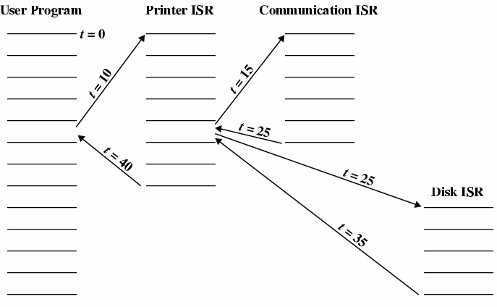

**Answer**

**Time for each process:**

1. Printer ISR: 10s.
2. Communication ISR: 10s.
3. Disk ISR: 10s.

**Priority:**

1. Communication ISR.
2. Disk ISR.
3. Printer ISR.